Alexis Fehring
Dr. Brian Bailie
English 2089
Assignment Three Draft
The discourse community I am apart of and feel very passionately about is Arbonne. The Arbonne community is like no other with integrity, positivity and a focus on health and wellness. If you’ve never heard of Arbonne before, it is probably because no one close to you is apart of this community. However, Arbonne has been around since 1980 and is named the #1 Brand for Health and Wellness Products. The founder, Peter Morck, created Arbonne for women to have a place to make a great income alongside a great culture by sharing clean, safe, nontoxic health and wellness products with friends and family across the world. To date, Arbonne does business in six countries. The documents I chose are; Arbonne’s Code of Ethics document via Direct Selling Association (DSA) guidelines, Arbonne’s ingredients and ethics policy and the manifesto of Arbonne.
I joined the company in December of 2017 soon after I turned 18 and could be apart of the business portion of Arbonne. I had used the health and wellness products for years as my mom is also in this discourse community. I jumped into the opportunity to create a little side income, better my health, and surround myself with an uplifting community.
Not being in the community, one may not know what all goes into sharing products you know and love. Arbonne is unique in being around for 40 years and the guidelines they hold their consultants to. The Code of Ethics, something we refer to as a company, is the most serious of documents for my team. If you do not abide by the code of ethics, you can lose your consult ID, also known as your ability to build clientele and grow a business. The DSA along with Arbonne’s Code of Ethics documents, provides a strict guideline for consultants telling us how, when and where we can share the business model and products of Arbonne.
The culture is created by Peter Morck and those who have been with the company since the beginning. This is what I like to call the “culture manifesto”.
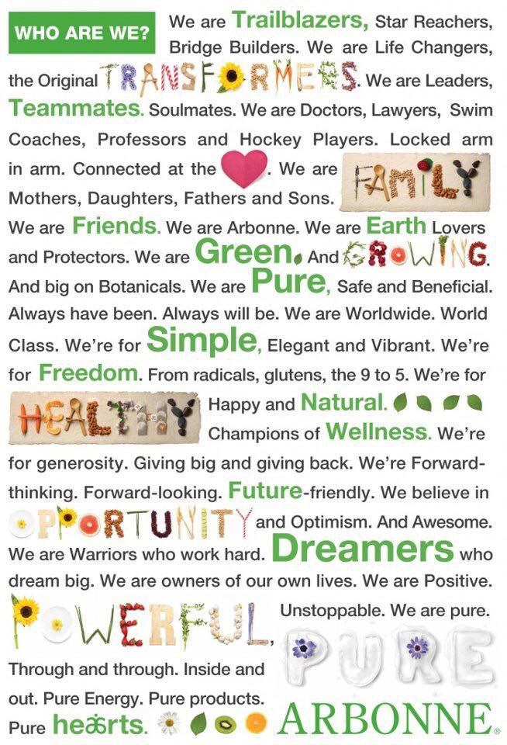

The motto above perfectly encompasses how a variety of backgrounds from schoolteachers, college students, lawyers and all the way to doctors can join together for the well being of our earth and our families through pure, safe and beneficial products.
The third document I chose is Arbonne’s ingredient policy. One who has never used Arbonne products or heard about the strict policy we hold, may not realize what is in their current skincare, makeup and nutrition products. Arbonne bans over 2,000 harmful ingredients from all products but some common ones are animal products and byproducts, artificial colors, sweeteners and fragrances, parabens, petroleum, gluten, peanuts and tree nuts, soy, mineral oil and high fructose corn syrup. This document of the ingredient policy is what consultants and clients can rely on to make sure the products they are consuming and good for you and for family.
Since joining this discourse community, I have an extreme income coming in weekly to help with daily expenses, a great community around me, a team of leaders and go getters and reached personal health goals. My mentors have created a community in Cincinnati and beyond that help each other without compensation but just out of generosity. I have created and lead a team to three promotions within. And finally, I am now my happiest and healthiest self with products I know and trust.
While speaking to an outside audience, a presentation would include all three documents I mentioned previously and would go more in depth about transformations and results with the products. This presentation to an outside audience would give the audience knowledge about what harmful ingredients may be in their current products, knowledge about Arbonne and the mission and the business model of network marketing.

https://www.arbonne.com/discover/promise/not-allowed.shtml
https://www.arbonne.com/discover/promise/index.shtml

