Alexis Fehring
Dr. Brian Bailie
English 2089
Assignment Three
The discourse community I am apart of and feel very passionately about is Arbonne. The Arbonne community is like no other with integrity, positivity and a focus on health and wellness. If you’ve never heard of Arbonne before, it is probably because no one close to you is a part of this community. However, Arbonne has been around since 1980 and is named the #1 Brand for Health and Wellness Products. The founder, Peter Morck, created Arbonne for women to have a place to make a great income alongside a great culture by sharing clean, safe, nontoxic health and wellness products with friends and family across the world. To date, Arbonne does business in six countries. The documents I chose are; Arbonne’s Code of Ethics document via Direct Selling Association (DSA) guidelines, Arbonne’s ingredients and ethics policy and the manifesto of Arbonne.
I joined the company in December of 2017 soon after I turned 18 and could now be involved in the business portion of Arbonne. I had used the health and wellness products for years as my mom is also in this discourse community. I jumped into the opportunity to create a little side income, better my health, and surround myself with an uplifting community. This business opportunity and the products elevated my life. Before starting to switch my eating habits, I had dizziness issues and would feel like I was going to pass out often, without actually passing out. After going to multiple doctors and trying out multiple medications, nothing was helping. In fact, the medication was bringing out other nasty side effects. That is when Arbonne nutrition products and the company’s ethics of being clean and pure came into play. My mom suggested I try being gluten free and soon after dairy free for a while. Doing this; in combination to supplementing with Arbonne nutrition products is what changed my health problems around.
Not being in the community, one may not know what all goes into sharing products you know and love. Arbonne is unique in being around for 40 years and the guidelines they hold their consultants to. The Code of Ethics, something we refer to as a company, is the most serious of documents for my team. If you do not abide by the code of ethics, you can lose your consultant ID, also known as your ability to build clientele and grow a business. The DSA along with Arbonne’s Code of Ethics documents, provides a strict guideline for consultants telling us how, when and where we can share the business model and products of Arbonne.
While the products changed my health for the better, the business and culture changed how I present myself professionally. If you were to look at my Instagram and Facebook page my “brand” or “face” is health and wellness entrepreneur. You can tell first thing when you get to my page. This is a very different look from what you will see from other college girls social media pages. Because of the culture, manifesto and simply how Arbonne has taught me to hold myself and present myself, my social media sites come off as professional and sophisticated with still a splash of college lifestyle.
The culture was created by Peter Morck as well as the few older folks that have been in the company for a while. This is what I like to call the “culture manifesto”.

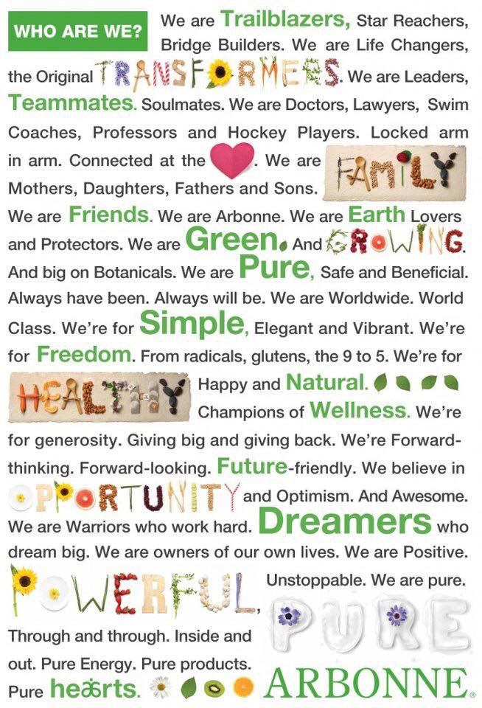

The motto above perfectly encompasses how a variety of backgrounds from schoolteachers, college students, lawyers and all the way to doctors can join together for the wellbeing of our earth and our families through pure, safe and beneficial products.
The third document I chose is Arbonne’s ingredient policy. One who has never used Arbonne products or heard about the strict policy we hold, may not realize what is in their current skincare, makeup and nutrition products. Arbonne bans over 2,000 harmful ingredients from all products but some common ones are animal products and byproducts, artificial colors, sweeteners and fragrances, parabens, petroleum, gluten, peanuts and tree nuts, soy, mineral oil and high fructose corn syrup. This document of the ingredient policy is what consultants and clients can rely on to make sure the products they are consuming and good for you and for family.
Since joining this discourse community, I have an extra income coming in weekly to help with daily expenses, a great community around me, a team of leaders and go getters and reached personal health goals. My mentors have created a community in Cincinnati and beyond, that help each other without compensation but just out of generosity. Our sidelines, someone who is not under us or above us by simply signed up under someone either, do not make commission off of our successes. However, the Cincinnati group of consultants get together a few times a year and brainstorm business ideas, create content and have fun. This is unlike any company or community I have ever been involved in previously. I have also now created and lead a team to three promotions. And finally, I am now my happiest and healthiest self with products I know and trust.
While speaking to an outside audience, a presentation would include all three documents I mentioned previously and would go more in depth about transformations and results with the products from myself and those close to me. This presentation to an outside audience would give the audience knowledge about what harmful ingredients may be in their current products, knowledge about Arbonne and the mission and the business model of network marketing.
While my experience in this discourse community has been great, of course there are drawbacks to being your own boss and going the entrepreneur route. I often deal with never being able to be “off”. At all times I have to hold myself to represent myself and my business in a positive way. I find myself getting stuck in the “hustle culture”, what a lot of YouTubers talk about these days. This is when the hustle and on the go, always busy lifestyle is glorified. It is almost like some have competitions with each other on who is the busiest and who isn’t taking care of their mental health more. While I definitely take plenty of time for myself to chill out and decompress, I also find myself wanting to do more, be busier, and hustle to reach to my goals faster than the universe has planned for me. Another possible downside when starting your own business within a network marketing company is judgement. Often times family, friends and strangers you’ve never met see a logo and think it is a “scam” or “scheme” without looking into the ethics of the company, what a scheme actually is, and educating themselves on literally anything. This may be the most frustrating part of being apart of Arbonne as a discourse community; dealing with the haters. However, usually those that hate, just want what you have and don’t know how to ask for it. After you get past the fear of what other people think of you in this business, you can skyrocket and go far. My friends and I in this business always say Arbonne is more than just selling skincare and protein powder, but it is also a personal development business. You will learn so much about yourself, grow and flourish if you take the time to help yourself mentally by maybe getting fit, reading, learning and growing.
After reading about my discourse community, I hope you are a little more educated on how a small network marketing company can change a life in more ways than one. It’s a crazy emotional rollercoaster being your own boss sometimes and having one more person that supports you emotionally or financially in this business really helps. Consider shopping small this holiday season, because entrepreneurs and small business owners do a happy dance when you do so. We will be way more thankful for your support than any Walmart or Target CEO ever will.

Works Cited
“Arbonne Ingredient Policy.” Not Allowed List, https://www.arbonne.com/discover/promise/not-allowed.shtml.
“Arbonne Ingredient Policy.” Not Allowed List, https://www.arbonne.com/discover/promise/not-allowed.shtml.
*see HW 11/5 for video embedding of Code of Ethics

